brain tumor image classification

A machine learning approach that classifies brain tumor type using deep learning modeling.
  - KENNETH NYANGWESO| DATA SCIENTIST| MACHINE LEARNIG ENGINEER

BUSINESS UNDERSTANDING:
Medical imaging plays a critical role in diagnosing brain tumors. Rapid and accurate classification of MRI images into tumor types can support radiologists and clinicians in making informed treatment decisions. The goal of this project is to leverage deep learning models to automatically classify brain MRI images into different tumor categories.
By deploying the model as a web application, hospitals and research institutions can have a scalable, accessible tool for aiding diagnosis.

PROBLEM STATEMENT:

Brain tumors can be of various types including glioma, meningioma, pituitary, or no tumor. Manual inspection of MRI scans is time-consuming and prone to human error.
The problem addressed in this project is:
Automatically classifying brain MRI images into four categories; glioma, meningioma, pituitary, and no tumor with high accuracy, enabling faster and more reliable diagnosis.

OBJECTIVES:

- Develop deep learning models capable of classifying brain MRI images.
- Compare multiple models to identify the most effective for this task.
- Deploy the best performing model as an interactive web application for demonstration.
- Provide insights and performance metrics for future improvements.

METRICS OF SUCCESS:

The models were evaluated based on:
- Accuracy – Overall proportion of correctly classified images.
- Recall – Sensitivity for each tumor class.
- F1-score – Balance between precision and recall for each class.
- Confusion Matrix – To visualize false positives and false negatives.
Target: Accuracy above 85% with balanced recall and F1-scores across all classes.

DATA UNDERSTANDING AND SOURCING:

- Dataset: Brain MRI images from publicly available medical imaging datasets.
- Classes: glioma, meningioma, no tumor, pituitary.
- Training set: 5600 images across all classes.
- Validation set: 1120 images across all classes.
- Image Size: 224x224 pixels after preprocessing for model input.
Each class has a sufficient number of images to enable robust model training.

DATA PREPROCESSING:

- Images were resized to 224x224 pixels.
- Normalization applied using ImageNet mean and standard deviation:
  - mean = [0.485, 0.456, 0.406]
  - std = [0.229, 0.224, 0.225]
- Images converted to tensors for PyTorch input.
- Data was organized into folders per class and loaded using PyTorch ImageFolder.
No data augmentation was applied for the current project but can be considered for further improvement.

MODELING:

Three transfer learning models were trained and deployed :
- RestNet-50
- EfficientNet-B0
- DenseNet121

Implementation Details:
- Framework: PyTorch
- Loss function: Cross-Entropy Loss
- Optimizer: Adam
- Training: GPU accelerated (T4 GPU)
- Epochs: 10–20 depending on model
- Evaluation metrics included confusion matrices, classification reports, and ROC curves.

EVALUATION:

METRIC/MODEL | RestNet-50 | EfficientNet-B0 | DenseNet-121
ACCURACY (%) | 87.60 | 98.84 | 98.57
RECALL(%) | 87.74 | 98.84 | 98.58
F1-SCORE(%) | 87.48 | 98.84 | 98.57

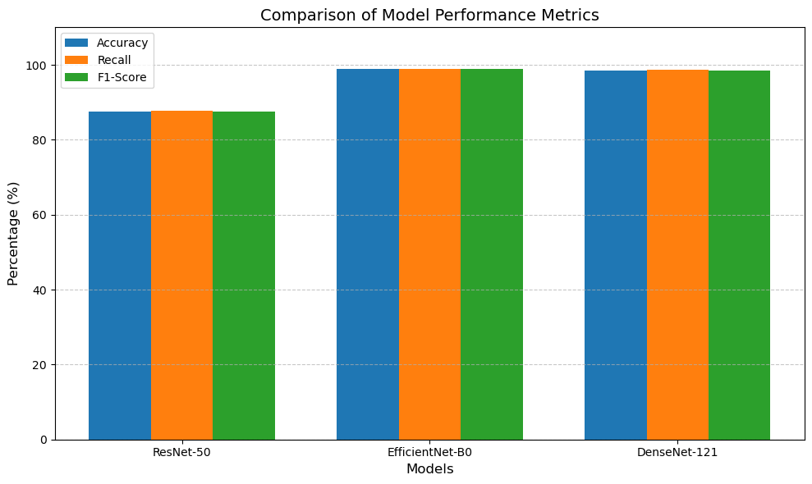

Key Insights:
- Overall Performance
  - EfficientNet-B0 and DenseNet-121 significantly outperform ResNet-50 across all metrics (~98% vs ~87%).
  - This indicates that the latter two models are much better suited for your dataset/task, likely due to their more modern architectures and efficient feature extraction.
- Accuracy
  - Accuracy is very high for EfficientNet-B0 (98.84%) and DenseNet-121 (98.57%), showing the models classify most samples correctly.
  - ResNet-50 is noticeably lower (87.6%), which could indicate underfitting or that the network is not capturing complex features as well.
- Recall
  - Recall is almost identical to accuracy for all models, meaning the models are good at correctly identifying positive cases (or the target class of interest).
  - EfficientNet-B0 has perfect alignment between accuracy and recall, suggesting no bias toward false negatives.
- F1-Score
  - F1-score is very close to accuracy and recall for all models, indicating a balanced performance between precision and recall.
  - Again, ResNet-50 lags behind, showing that it may produce more false positives/negatives compared to the other two models.
- Comparison Between EfficientNet-B0 and DenseNet-121
  - Both models perform almost equally, but EfficientNet-B0 slightly edges out DenseNet-121 by a tiny margin (~0.3%).
  - EfficientNet-B0 is also lighter and faster than DenseNet-121, making it potentially better for deployment in real-time or resource-constrained environments.

Summary:
- Best performing model: EfficientNet-B0 (slightly better than DenseNet-121 and more efficient).
- ResNet-50: Adequate but significantly worse, might not be suitable for high-stakes deployment.
- Balanced performance: All top two models have high recall and F1-score, meaning they handle class distribution well and are reliable in predicting the target.

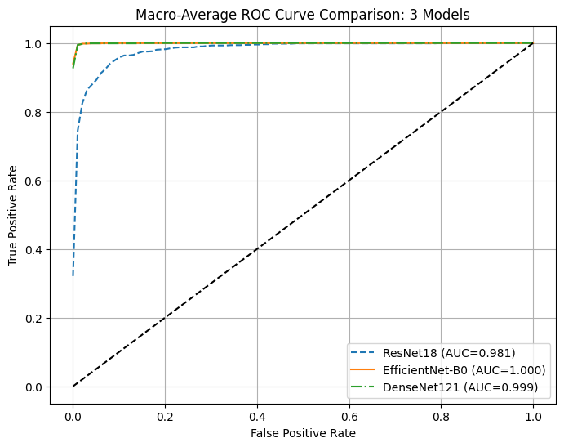

Model Comparison via ROC Curves
- ResNet-18 (blue dashed line) has a slightly lower ROC curve, with AUC = 0.981.
  - This indicates strong performance, but it is slightly behind the other two models.
- EfficientNet-B0 (orange solid line) achieves a perfect ROC curve with AUC = 1.000.
  - This means it perfectly separates positive and negative classes on your dataset.
- DenseNet-121 (green dash-dot line) also performs extremely well with AUC = 0.999, almost indistinguishable from EfficientNet-B0.

BEST MODEL (EFFICIENTNET B0) CONFUSION MATRIX:
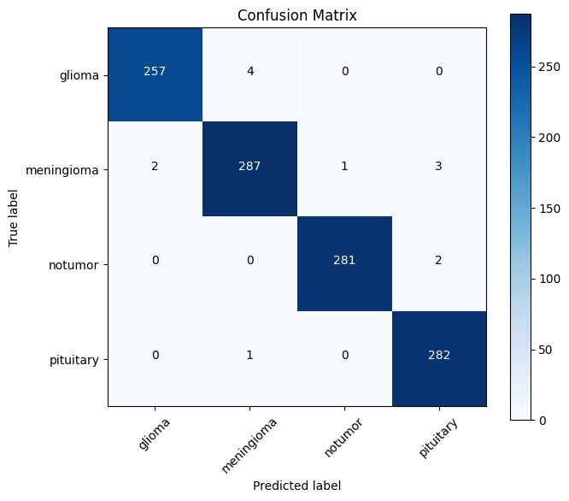
Insights
- Most Confusions:
  - Meningioma vs Glioma (2 cases misclassified)
  - Meningioma vs Pituitary (3 cases misclassified)
  - These are very few, showing the model captures features of each tumor type well.
- Overall Accuracy: Extremely high; very few errors across ~1140+ samples in total.
- Class-wise Sensitivity:
  - All classes have high recall, with Glioma, NoTumor, and Pituitary almost perfect.
  - Meningioma is slightly more confused but still >98% correct.

DEPLOYMENT:

- Framework: Streamlit
- Model Saved: efficientnet_model.pth (PyTorch)
- Features:
  - Upload MRI image for prediction
  - Shows predicted tumor class and confidence
  - Probability bar chart visualization
- Deployment Options:
  - Streamlit Community Cloud (live link possible)
  - Local run via streamlit run app.py
This allows stakeholders to interactively test the model on new images.

EXPECTED RESULTS:

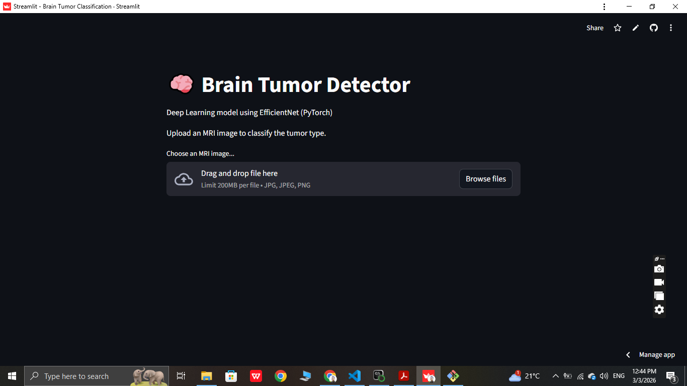

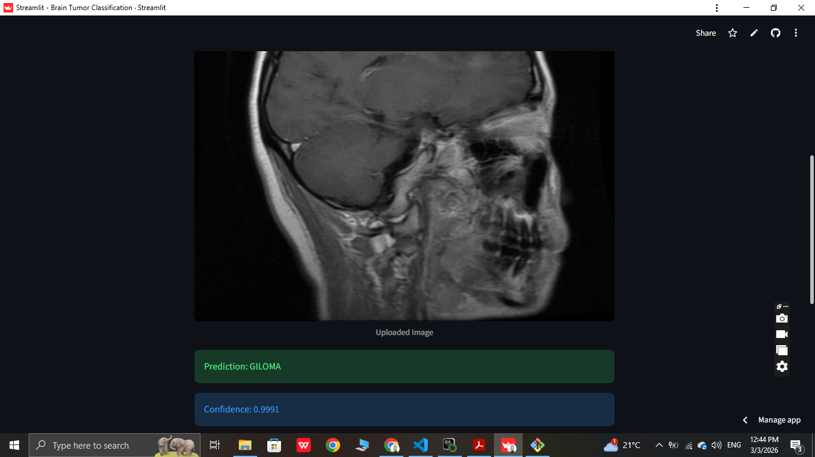

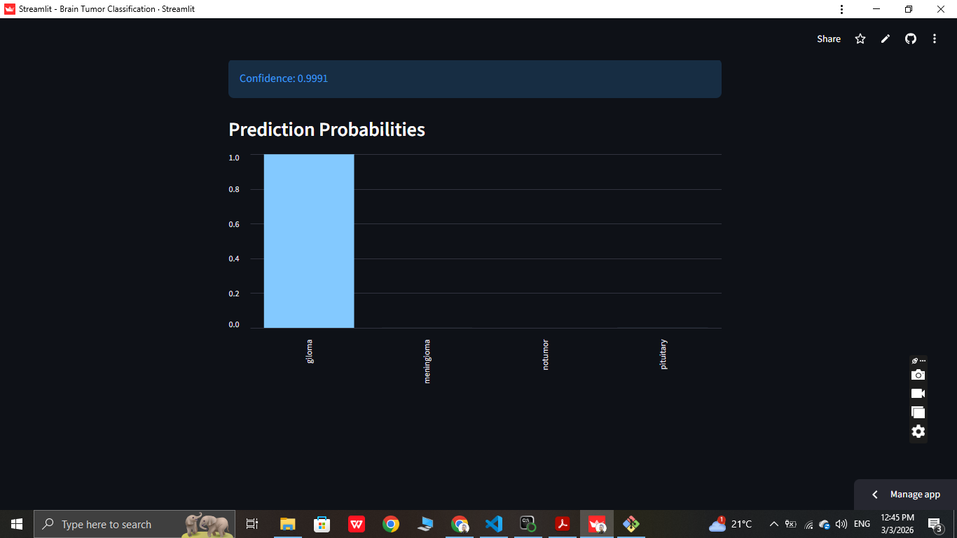

Video demonstration link (copy the link below to view live demonstration of the brain tumor classifier):
Link: https://drive.google.com/file/d/1KZSMKYDckz_CbDMhihBngb5glYVnoFJc/view?usp=drive_link

CONCLUSIONS:

- EfficientNet-B0 demonstrated outstanding performance on brain MRI classification.
- Deep learning can automate tumor detection, reduce radiologist workload, and increase diagnostic speed.

RECOMMENDATIONS:

- Expand dataset with more diverse MRI images for robustness.
- Apply data augmentation to further improve generalization.
- Integrate Grad-CAM or attention maps for explainability in clinical settings.
- Deploy as a web service for real-time hospital use.
- Monitor model performance with new incoming data and retrain periodically.

